We are pleased to announce the National Museum of Funeral History’s 31st Annual Charity Golf Classic scheduled for Monday, November 10, 2025, at 9:00 a.m. at Kingwood Country Club in Kingwood, Texas. We invite you to attend this five-man scramble tournament, which is an excellent opportunity to network with business executives and funeral industry professionals from across the country, as well as support the museum. In 2024, more than 70 sponsors and 375 players supported this charity event.
We also invite you to join us at the Sponsor Appreciation Night on November 9, 2025, from 5-7 p.m. at the National Museum of Funeral History. At the event, light hors d’oeuvres and complimentary cocktails will be served among the museum exhibits. Guests will have the opportunity to check-in early for the tournament and bid on the silent auction items.
Our founder, Mr. R. L. Waltrip’s dream became a reality in 1992, where his vision for the museum was to house educational exhibits of funerary items that tell the historical evolution of the funeral profession. Today, the museum houses the nation’s largest collection of funeral artifacts and continues to enlighten visitors about the rich history of funeral service. Please join us at the museum for an amazing evening of sharing memories and stories amongst the exhibits.
Your continued support ensures the growth and preservation of the museum and development of educational programs along with both permanent and temporary exhibits. Enclosed you will find information outlining the sponsor opportunities and the timeline of events. Confirm your sponsorship today and register online at www.nmfh.org. Entry must be received by October 17. We’re accepting up to 375 players this year. Be sure to register while spots are still open. If you are unable to register online, contact the museum at 281-876-3063 and ask for Lucy Gonzalez or Genevieve Keeney.
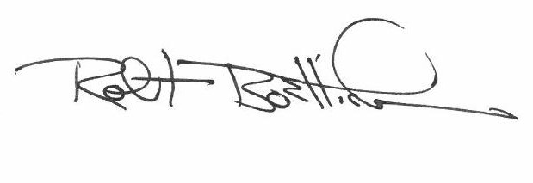
We appreciate your support and hope you can join us at the Charity Golf Classic and Sponsor Appreciation Night. Sincerely,

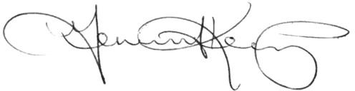
Robert M. Boetticher, Sr. Genevieve G. Keeney
Chairman President/CEO

Support the Museum: Become a Tournament Sponsor
Want maximum visibility on the course? Consider becoming a Flag Sponsor. Pair it with another sponsor level to further boost your Company’s presence at the events.
All contributions are tax deductible to the extent allowable by law. Register online at www.nmfh.org. Entry must be received by October 17. We’re accepting up to 375 players this year. Be sure to register while spots are still open. For additional information, contact Lucy Gonzalez or Genevieve Keeney at 281-876-3063.

Platinum Sponsor - $25,000
- 10 player fees
- 4 guests to attend exclusive breakfast with museum executives
- Company name on banner displayed at all tournament events
- Merchandise voucher for each player

Gold Sponsor - $20,000
- 15 player fees
- Company name on banner displayed at all tournament events
- Merchandise voucher for each player

Silver Sponsor - $15,000
- 10 player fees
- Company name on banner displayed at all tournament events
- Merchandise voucher for each player

Bronze Sponsor - $10,000
- 5 player fees
- Company name on banner displayed at all tournament events
- Merchandise voucher for each player

Golf Cart Sponsor (1 available) - $10,000-Sold Out
- Company name displayed on sign in each golf cart

Flag Sponsor (18 available) - $5,000 
- Company logo on flag attached to flagstick and displayed at a green on each course
- Framed commemorative flag

Beverage Cart Sponsor (3 available) - $6,000
- Company name on sign displayed at beverage rest stops and one beverage cart per course

Longest Drive Sponsor (3 available) - $5,000
- Company name on sign displayed at the long drive hole on each course

Photo Booth Sponsor - $7,500 

Sunday @ the Sponsor Appreciation Night
- Includes your logo on 400 printed photos & unlimited digital images
- Logo on all digital 360 Photo Booth videos

Photo Booth Sponsor - $5,000

Monday @ the Kingwood Country Club
- Includes your logo on 600 printed photos & unlimited digital images

Closest to the Pin Sponsor (3 available) - $5,000
- Company name on sign displayed at the closest to the pin hole on each course

Driving Range Sponsor (3 available) - $5,000
- Company name on sign displayed at practice areas

Team of Five Sponsor - $4,000
- 5 player fees
- Merchandise voucher for each player

Course Sponsor - $2,000
- Company name on individual sign displayed on each course

Friend of the Museum - Donations under $1,000
- Company name on sign displayed at check-in

Individual Player - $1,000
- 1 player fee
- Merchandise voucher

Ride Along - $400
  - Half golf cart, lunch & post tournament award reception
  - Merchandise voucher

Golf Club Rentals - $200
Credit card payment is due at time of request. A two-week cancellation notice required for full refund.

Post Tournament Award Reception Only - $100
  - Meal at Kingwood Country Club

2025 Timeline of Events

Friday, October 17 – Sponsor Registration Deadline

Register online at www.nmfh.org.

Entry must be received by October 17. We’re accepting up to 375 players this year. Be sure to register while spots are still open.

If you are unable to register online, contact Lucy Gonzalez or Genevieve Keeney at 281-876-3063 for assistance.

Sunday, November 9 - Sponsor Appreciation Night
National Museum of Funeral History / 415 Barren Springs Drive, Houston, TX

5:00 - 7:00 p.m. Early player check-in for the tournament
Enjoy complimentary cocktails and light hors d’oeuvres
Bid on silent auction items
View the latest exhibits to see how your donations impact the museum

Monday, November 10 - Charity Golf Classic Tournament
Kingwood Country Club / 1700 Lake Kingwood Trail, Kingwood, TX

7:00 a.m. Player check-in and merchandise voucher pick-up opens
Enjoy light continental breakfast
7:30 a.m. Exclusive Platinum Sponsor breakfast begins
9:00 a.m. Shot-gun start (lunch available on course)

2:30 p.m. Deadline to turn in scorecards

3:00 p.m. Post-tournament award reception and meal

5:00 p.m. Deadline to use merchandise voucher

